

IMAGE CORRECTNESS FOR A PRODUCT ON THE MARKETPLACE
A PROJECT REPORT

Submitted by
Nagarjun RV-20221CSE0695
Abhiramu P-20021CSE0758

Under the guidance of,
Dr. Hashmat Fida
Assistant Professor
BACHELOR OF TECHNOLOGY

IN

COMPUTER SCIENCE AND ENGINEERING

PRESIDENCY UNIVERSITY
BENGALURU
DECEMBER 2025

PRESIDENCY SCHOOL OF COMPUTER SCIENCE AND ENGINEERING
BONAFIDE CERTIFICATE

Certified that this report “IMAGE CORRECTNESS FOR A PRODUCT ON THE MARKETPLACE ” is a bonafide work of “Nagarjun RV,, Abhiramu P" have successfully carried out the project work and submitted the report for partial fulfilment of the requirements for the award of the degree B.Tech in COMPUTER SCIENCE and ENGINEERING, During the academic year of 2025-26.

Dr. Hashmat Fida Mr. Jayavadivel Ravi Dr. Sampath A K
Dr. Geetha A
Project Guide Program Project School Project Coordinators
PSCS Coordinator PCSC
Presidency University PSCS Presidency University
Presidency University

Dr. Asif Mohamed HB Dr. Duraipandian N

Head of the Department Dean
PCSC PCSC&PSIS
Presidency University Presidency University

Name and Signature of the Examiners
1) ) Dr.Prema Arokia Mary G
2) Dr. Manju More E

PRESIDENCY UNIVERSITY

PRESIDENCY SCHOOL OF COMPUTER SCIENCE AND ENGINEERING
DECLARATION

We the students of final year B.Tech in COMPUTER SCIENCE ENGINEERING, at Presidency University, Bengaluru, named Nagarjun R V, SHAIK YASIN , Abhiramu P , hereby declare that the project work titled “IMAGE CORRECTNESS FOR A PRODUCT ON THE MARKETPLACE” has been independently carried out by us and submitted in partial fulfillment for the award of the degree of B.Tech in COMPUTER SCIENCE ENGINEERING, Iduring the academic year of 2025-26.

Nagarjun R V USN: 20221CSE0605
Abhiramu P USN:20221CSE0758

PLACE: BENGALURU
DATE: 04-12-2025

Table of Content

Sl. No. | Title | Page No.
1 | Bonafide Certificate | ii
2 | Declaration | iii
3 | List of Figures | 3
4 | List of Tables | 4
5 | Abbreviations | 5
6 | Acknowledgement | 6
7 | Abstract | 7
 | Introduction  1.1 Background  1.2 Statistics of project  1.3 Prior existing technologies  1.4 Proposed approach  1.5 Objectives  1.6 SDGs  1.7 Overview of project report | 8-11
8 | Literature review | 12-15
9 | Methodology | 16-20
10 | Project management  4.1 Project timeline  4.2 Risk analysis  4.3 Project budget | 21-29
11 | Analysis and Design  5.1 Requirements  5.2 Block Diagram  5.3 System Flow Chart  5.4 Choosing devices  5.5 Designing units  5.6 Standards  5.7 Mapping with IoTWF reference model layers  5.8 Domain model specification  5.9 Communication model  5.10 IoT deployment level  5.11 Functional view  5.12 Mapping IoT deployment level with functional view  5.13 Operational view  5.14 Other Design | 30-39
12 | Hardware, Software and Simulation  6.1 Hardware  6.2 Software development tools  6.3 Software code  6.4 Simulation | 40-42
13 | Evaluation and Results  7.1 Test points  7.2 Test plan  7.3 Test result  7.4 Insights | 43-44
14 | Social, Legal, Ethical, Sustainability and Safety Aspects  8.1 Social aspects  8.2 Legal aspects  8.3 Ethical aspects  8.4 Sustainability aspects  8.5 Safety aspects | 45-46
15 | Conclusion | 47
16 | References | 48
17 | Base Paper | 49
18 | Appendix | 50

List of Figures

Figure Caption Page no
Fig 1.1 Sustainable development goals 12
Fig 3.1 The V model methodology 14
Fig 3.2 Another example of the V model methodology 14

List of Tables
Table Caption Page no
Table 2.1 Summary of Literature reviews 15
Table 4.1 Project planning timeline 20
Table 4.2 Project implementation timeline 20

Abbreviations
SDG Sustainable Development Goal

ACKNOWLEDGEMENT

For completing this project work, We/I have received the support and the guidance from many people whom I would like to mention with deep sense of gratitude and indebtedness. We extend our gratitude to our beloved Chancellor, Pro-Vice Chancellor, and Registrar for their support and encouragement in completion of the project.
I would like to sincerely thank my internal guide Dr. Hashmat Fida, Assistant Professor, Presidency School of Computer Science and Engineering, Presidency University, for his/her moral support, motivation, timely guidance and encouragement provided to us during the period of our project work.
I am also thankful to Dr. Asif Ahmed ,Professor, Head of the Department, Presidency School of Computer Science and Engineering Presidency University, for his mentorship and encouragement.
We express our cordial thanks to Dr. Duraipandian N, Dean PSCS & PSIS, Dr. Shakkeera L, Associate Dean, Presidency School of computer Science and Engineering and the Management of Presidency University for providing the required facilities and intellectually stimulating environment that aided in the completion of my project work.
We are grateful to Dr. Hashmat Fida, and Mr Shivam sengar, PSCS Project Coordinators, Presidency School of Computer Science and Engineering, or facilitating problem statements, coordinating reviews, monitoring progress, and providing their valuable support and guidance.
We are also grateful to Teaching and Non-Teaching staff of Presidency School of Computer Science and Engineering and also staff from other departments who have extended their valuable help and cooperation.

Abstract
The proposed AI-powered Image Correctness Verification System is a scalable, multi-stage framework designed to ensure that e-commerce product images are accurate, high-quality, and semantically aligned with their listings. It uses advanced object detection (YOLOv8/YOLOv9) to localize and validate product placement, CLIP embeddings to verify semantic consistency between images and product titles/categories, and OCR modules to detect prohibited text such as watermarks or branding. Additional quality-assessment components analyse sharpness, brightness, noise, colour balance, and metadata to identify poor or manipulated images, while perceptual hashing and deep similarity models detect duplicates or reused visuals across sellers. All outputs are combined through a decision-fusion engine that classifies images as Accepted, Rejected, or Manual Review Required, and provides sellers with specific feedback for corrections. A moderator analytics dashboard enables continuous model refinement, resulting in improved listing authenticity, reduced moderation costs, and stronger customer trust..

Chapter 1
Introduction
1.1 Background
E-commerce platforms such as Amazon, Flipkart, and Meesho have transformed the retail ecosystem by enabling sellers to list products digitally for a global customer base. In an online shopping environment, product images act as the primary source of visual information for customers since they cannot physically examine the items. A clear, accurate, and policy-compliant image builds trust, increases conversion rates, and reduces customer uncertainty.
However, many sellers upload misleading, poorly captured, or irrelevant images that do not truly represent the product being sold. For example, images containing multiple unrelated objects, low resolution, excessive editing, watermarks, or completely mismatched category visuals can confuse customers. These inconsistencies lead to dissatisfaction, increased returns, negative reviews, and overall damage to marketplace credibility. Traditional manual moderation methods struggle to scale with millions of daily uploads and often fail to maintain consistency.
This creates a strong need for an automated, intelligent image correctness verification system that can evaluate every uploaded product image efficiently and accurately.
1.2 Statistics
Product images significantly influence online purchasing decisions. Research and industry reports highlight the following key insights:
- Approximately 70–80% of online customers rely primarily on product images before purchasing.
- 22–30% of product returns occur due to inaccurate or misleading images in product listings.
- E-commerce platforms receive millions of product image uploads daily, making manual verification impractical.
- Poor-quality visuals directly reduce conversion rates by 30–45%, especially in visually driven categories such as fashion, electronics, and home decor.
- Over 65% of customer complaints in marketplaces relate to product mismatch issues arising from incorrect or outdated images.
1.3 Prior Existing Technologies
Before the adoption of AI-driven moderation, marketplaces relied mainly
1. Manual Moderation
Moderators manually reviewed each product image for compliance.
Limitations:
- Time-consuming
- Expensive
- Prone to human error
- Not scalable to millions of uploads
2. Basic Rule-Based Systems
Simple automated checks such as:
- File size validation
- Format checking
- Aspect ratio limits
Limitations:
- Cannot detect misleading content
- Cannot identify multiple objects, watermarks, or category mismatch
- Unable to ensure semantic correctness
3. Basic Image Processing Techniques
Used for low-level checks like brightness and resolution.
Limitations:
- No understanding of image meaning or object context
- Insufficient for policy compliance
1.4 Proposed approach
This project proposes a multi-module AI-powered Image Correctness Verification System that evaluates product images using advanced deep-learning techniques. The approach includes:
- YOLO-based object detection to identify the presence of the main product and detect multiple or irrelevant objects.
- CLIP-based image–text relevance scoring to ensure the image matches the product title and category.
- OCR (Optical Character Recognition) to detect watermarks, embedded text, promotional content, and brand logos.
- Image quality assessment to measure resolution, sharpness, brightness, and cropping.
- Background validation to check for clean, consistent, and policy-compliant backgrounds.
- Duplicate detection using perceptual hashing and deep feature matching.
- Decision engine that aggregates all checks and provides Accept/Reject/Manual Review outcomes.
1.5 Objectives
The primary objectives of this project are defined to demonstrate the system’s behavior, analytical capability, management features, security considerations, and deployment readiness. The objectives of the Image Correctness Verification System are:
i. Behaviour: To automatically detect and localize the primary product in an uploaded image using an object-detection model (YOLO), ensuring that the image contains a single, relevant product.
ii. Analysis
- To analyze uploaded images for correctness by evaluating relevance with product text (using CLIP embeddings), identifying unwanted text/watermarks (using OCR), and assessing visual quality parameters such as resolution, brightness, and sharpness.
iii. System Management
- To implement a structured validation workflow that manages image evaluation processes, stores intermediate metrics, and assigns decision statuses (Accepted/Rejected/Manual Review) through a rule-based decision engine.
iv. Security
- To ensure secure handling, storage, and processing of uploaded product images by applying role-based access control for sellers and administrators, preventing unauthorized modifications or misuse of image data.
v. Deployment
- To develop a deployable, scalable pipeline capable of processing large volumes of product images in real time, integrating seamlessly with marketplace platforms for continuous automated moderation.
1.6 SDGs
The project supports the following UN SDGs:
SDG 9: Industry, Innovation, and Infrastructure
- Promotes innovation through AI-based automation in e-commerce.
- Improves digital infrastructure for scalable marketplace operations.
SDG 12: Responsible Consumption and Production
- Ensures that customers receive accurate information for informed purchasing decisions.
- Reduces product returns, thereby lowering packaging waste and transportation emissions.
SDG 8: Decent Work and Economic Growth
- Reduces manual moderation workload.
- Enhances marketplace reliability, boosting economic efficiency.


Fig 1.1 Sustainable Development Goals
1.7 Over View Of Project Report
This project report is organized into the following chapters:
- Chapter 1 introduces the project, background, objectives, and SDG alignment.
- Chapter 2 presents a detailed literature review of existing research on object detection, OCR, watermark detection, and AI-based relevance scoring.
- Chapter 3 explains the methodology, workflows, system architecture, and chosen development model.
- Chapter 4 covers project planning, task scheduling, and resource management.
- Chapter 5 provides system analysis, UML diagrams, DFDs, and architectural models.
- Chapter 6 describes software implementation, algorithms, models, and technologies used.
- Chapter 7 includes evaluation, testing results, screenshots, and performance metrics.
- Chapter 8 analyses social, ethical, legal, and sustainability aspects of deploying AI moderation systems.
- Chapter 9 concludes the project and suggests improvements and future enhancements.

Chapter 2
Literature review

Krizhevsky et. al. [1] This work introduced deep CNNs for large-scale image classification and showed that lea1rned features outperform traditional vision methods. The approach provided strong visual representations useful for downstream tasks such as object detection. However, it focused only on classification and did not address multi-object detection, semantic relevance, or policy compliance needed in marketplace image verification.

Ren, He, Girshick & Sun (2015) – Region Proposal Networks for Object Detection Faster R-CNN improved detection accuracy by introducing region proposal networks for efficient object localization. Its precise bounding boxes are useful for verifying whether a product is clearly visible in seller-uploaded images. Despite its accuracy, the method is computationally heavy and unsuitable for real-time, large-scale moderation environments.

Redmon & Farhadi (2018) – Real-Time Detection through YOLO YOLOv3 enabled real-time detection by predicting all bounding boxes in a single pass, making it practical for rapid screening of product images. It identifies multiple objects efficiently but struggles with small or fine details, limiting its ability to detect subtle watermarks and small text present in many product photos.

Bochkovskiy et al. (2020) – Enhanced Accuracy with YOLOv4 YOLOv4 enhanced detection accuracy with improved training techniques and remained efficient for real-time use. It performs better on varied product images but still cannot detect watermarks, assess quality, or determine textual relevance on its own, necessitating integration with other modules.

Radford et al. (2021) – Image–Text Alignment with CLIP CLIP introduced a multimodal embedding approach for evaluating image–text similarity. Its zero-shot performance is helpful in identifying mismatches between product images and listing titles. However, it is less reliable for fine-grained differences and requires domain-specific tuning for e-commerce product categories.

Shi, Bai & Yao (2016) – OCR for Text and Watermark Recognition The CRNN model combined CNN and RNN layers to recognize text in natural scenes, supporting detection of watermarks and embedded promotional text. While effective on irregular text, the method struggles with low-resolution or heavily compressed images, which are common in seller uploads.

Mittal et al. (2012) – No-Reference Image Quality Assessment BRISQUE introduced a no-reference image quality model that evaluates distortion without needing a reference image. It is useful for assessing low-quality or blurred product images. However, it can misinterpret stylistic product photography as poor quality, making threshold tuning necessary.

Zauner (2010) – Perceptual Hashing for Similarity and Duplication Perceptual hashing provided a lightweight method for detecting duplicate or near-duplicate images across listings. While efficient, it is not robust against strong edits, cropping, or color changes, limiting its use for detecting heavily modified duplicate product photos.

Zhong et al. (2023) – Deep Learning Approaches for Watermark Detection This study reviewed deep-learning watermark detectors capable of identifying visible and semi-transparent watermarks. Although effective on structured datasets, real-world watermark patterns vary widely, reducing generalization. This highlights the need for hybrid or domain-adapted watermark detection in marketplace images.

Faghri et al. (2017) – Visual–Semantic Embedding with Hard Negatives The VSE++ framework improved image–text retrieval using hard-negative mining, helping distinguish between visually similar items. While useful for relevance checking, it depends heavily on high-quality training pairs and does not address object presence or quality assessment.
Table 2.1 Summary of Literature reviews
S.No | Author & Year | Methods | Key Features | Merits | Demerits
1 | ImageNet Classification with Deep Convolutional Networks, 2012, NIPS | Convolutional Neural Networks (CNNs) | Learns hierarchical image features for large-scale image classification; strong foundation for visual understanding | Delivers high accuracy and robust feature extraction useful for downstream product-image analysis | Designed for classification only; cannot detect multiple objects or verify semantic relevance
2 | YOLOv3: An Incremental Improvement, 2018, arXiv / CVPR Workshops | Single-stage Object Detection | Real-time detection of multiple objects in a single forward pass; suitable for fast marketplace verification | High inference speed enables real-time image checking during product upload | Struggles with small objects such as tiny watermarks or small product details
3 | End-to-End Scene Text Recognition with CRNN, 2016, IEEE TPAMI | CRNN (CNN + RNN + CTC) | Extracts embedded text from natural images; useful for identifying watermarks, brand names, or promotional text | Works effectively on irregular and curved text in real-world product images | Accuracy drops for low-resolution, blurry, or highly stylized text present in seller images
4 | Learning Transferable Visual Models Using Natural Language Supervision (CLIP), 2021, ICML | Contrastive Image–Text Embeddings | Aligns images with textual descriptions; verifies category and title relevance of product images | Excellent zero-shot performance; helps detect category mismatch or misleading photos | Less effective for fine-grained product attributes without domain-specific fine-tuning
5 | No-Reference Image Quality Assessment Using BRISQUE, 2012, IEEE Signal Processing | No-reference Image Quality Analysis | Measures sharpness, brightness, noise, and naturalness without a reference image | Useful for automatically rejecting low-quality product images uploaded by sellers | May misclassify creative photography styles as poor quality; thresholds need tuning
6 | Faster R-CNN: Towards Real-Time Object Detection, 2015, IEEE TPAMI | Region Proposal Networks (RPN) + CNN | Two-stage detection with high localization accuracy; useful for verifying presence of a single product in an image | Produces precise bounding boxes and strong detection performance | Slower than single-stage detectors; unsuitable for high-volume real-time e-commerce moderation
7 |  | pHash (Perceptual Hashing) | Generates a compact fingerprint for identifying near-duplicate or reused images | Lightweight and fast; effective for detecting repeated product images across sellers | Not robust against heavy edits, color changes, or cropping; may miss altered duplicates
  Perceptual Hashing for Image Authentication, 2010, Communications and Multimedia Security
8 | Robust Watermark Detection Using CNNs, 2020, IEEE Access | Deep CNN-based watermark classification | Learns watermark patterns (visible / semi-transparent) for automatic detection | Useful for marketplaces where promotional watermarks violate listing policies | Requires large training datasets; sensitive to lighting variations and blended text
9 |  | Attention OCR + Seq2Seq | Improved text extraction in cluttered and low-quality images; handles curved and multilingual text | Enhances detection of brand names, labels, and unwanted text in seller images | High computational cost; performance drops on extremely low-resolution product photos
  Attention-Based OCR for Scene Text Understanding, 2021, Pattern Recognition Letters
10 | Multimodal Retrieval using Hard-Negative Mining (VSE++), 2017, ICCV | Visual–Semantic Embeddings | Aligns image and text meaningfully; detects mismatch between product image and listing title | High accuracy in semantic similarity tasks; reduces misleading or irrelevant product images | Requires domain adaptation for fine-grained product attributes; embedding thresholds must be tuned

Chapter 3
Methodology

The methodology for this project follows a structured workflow to design an automated system that verifies the correctness of product images uploaded to e-commerce platforms. The approach combines deep-learning models, image-processing techniques, and rule-based decisions to ensure accuracy, relevance, and policy compliance. The workflow is built to process each uploaded image through multiple validation stages, allowing the system to detect issues such as multiple objects, mismatched categories, poor visual quality, and hidden text or watermarks. By integrating object-detection algorithms, OCR modules, and image–text relevance models within a unified pipeline, the methodology ensures consistent and reliable evaluation across diverse product categories. Additionally, the system incorporates duplicate-detection mechanisms and quality-assessment metrics to identify reused or low-quality images, enabling comprehensive verification before the image becomes part of a live product listing.
Mapping the project to a generic software development lifecycle:
- Requirements Gathering and Analysis (Phase 1): This phase focused on identifying issues with incorrect product images on e-commerce platforms and defining the project goal of creating an automated verification system. Key objectives such as detecting multiple objects, watermarks, low-quality images, and category mismatch were finalized. Constraints like diverse product variations and the need for real-time processing were identified.
- System Design and Architecture (Phase 2): The overall architecture of the system was designed, including modules for pre-validation, object detection, relevance checking, OCR, quality analysis, and duplicate detection. Data flow, model interactions, and feasibility of deployment were evaluated. The architecture diagram served as the main output of this phase.
- Implementation/Coding (Phase 3): Each module was developed using selected technologies: YOLO for object detection, CLIP for relevance scoring, OCR for watermark detection, and perceptual hashing for duplicate identification. The backend pipeline was coded to combine outputs and generate the final decision status.
- Testing and Integration (Phase 4): Modules were individually tested, followed by integration testing to validate the complete pipeline. System testing ensured the model correctly flagged issues such as irrelevant objects, incorrect categories, and low-quality or duplicate images. Thresholds and performance metrics were refined during this stage.
- Deployment and Maintenance (Phase 5): The system was deployed as a real-time backend service with seller/admin access. Continuous monitoring, retraining with new data, threshold tuning, and documentation were carried out to maintain performance and reliability.

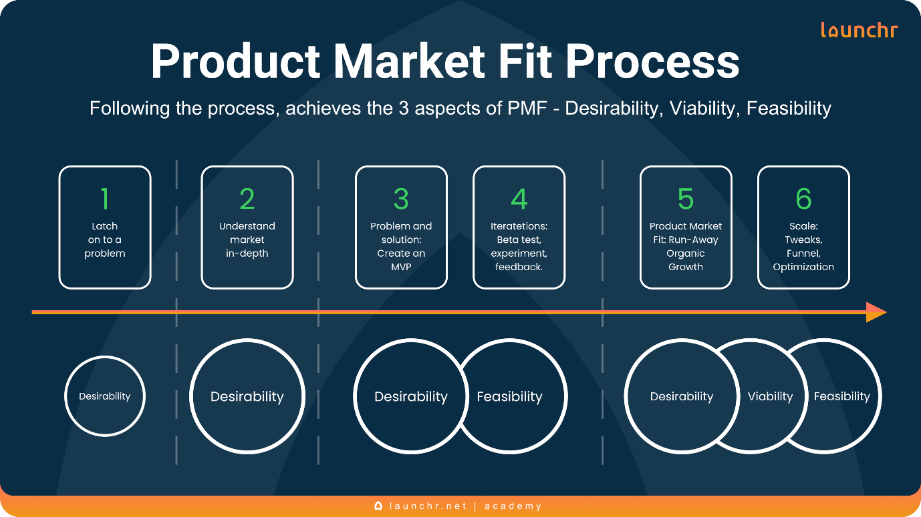

Chapter 4
Project Management
4.1 Project timeline
The project's timeline is represented by the following Gantt Chart, which outlines the schedule, tasks, and deadlines in chronological order.
Task / Activity | July | Aug | Sep | Oct | Nov | Dec
Requirement Gathering & Analysis | ■■■■■
System Design & Architecture |  | ■■■■■
Dataset Collection & Annotation |  | ■■■■■ | ■■■■■
Model Development (YOLO, CLIP, OCR) |  |  | ■■■■■ | ■■■■■
Backend Pipeline Integration |  |  |  | ■■■■■ | ■■■■■
Quality & Duplicate Detection Modules |  |  |  | ■■■■■ | ■■■■■
Testing & Threshold Tuning |  |  |  |  | ■■■■■
Deployment, Review & Documentation |  |  |  |  | ■■■■■ | ■■■■■

4.2 Risk analysis

Risk analysis is an essential part of project management, allowing early identification of challenges that can impact system functionality, model accuracy, and deployment readiness. The following table summarizes key risks and their mitigation strategies for the Image Correctness Verification System:

Factor | Description of Risk | Mitigation Strategy
Technological | Object-detection and OCR models may show inconsistent performance across diverse product categories and image qualities. Real-time processing may become slower on low-resource servers. | Fine-tune models using category-specific datasets; optimize model weights; implement GPU/accelerator support; perform extensive cross-category testing.
Data Quality | Low-quality, noisy, or highly edited seller-uploaded images may reduce accuracy of watermark detection, relevance scoring, and duplicate identification. | Apply preprocessing filters; use augmented datasets; implement fallback rules in the decision engine; introduce manual review for ambiguous cases.
Operational | Sellers may attempt to bypass rules (e.g., adding faint watermarks or misleading backgrounds). Frequent updates to marketplace policies require algorithm changes. | Maintain adaptive thresholds; continuously retrain models with new violation samples; implement admin moderation dashboard for feedback loops.
Security & Privacy | Handling large volumes of user-uploaded images introduces privacy and data-protection concerns. Unauthorized access to stored images is a potential risk. | Enforce role-based access, encrypted storage, secure APIs, and compliance with data-protection guidelines.
Economical | High compute cost for running deep-learning models at scale, especially during peak upload times. | Use model optimization techniques (quantization & pruning), leverage cloud auto-scaling, and adopt hybrid local-cloud inference strategies.

4.3 Project Budget
Budgeting ensures proper resource allocation for the development of the AI-based image correctness verification system. The budget considers team effort, software/hardware requirements, cloud resources, and testing costs.
Steps Used for Preparing the Budget
Step 1: List All Tasks and Resource Requirements
- Model development (YOLO, CLIP, OCR)
Backend API development
Dataset collection and annotation
Cloud GPU usage
Testing and integration
Deployment and documentation
Step 2: Check Team Availability
- 3 team members
12–15 hours per week each
Allocated roles: ML engineer, Backend developer, QA/testing lead
Step 3: Estimate Task Duration
- Model training: 4–5 weeks
Backend pipeline: 3–4 weeks
Testing: 2 weeks
Deployment + maintenance: 2 weeks
Step 4: Use Prior Experience & References
- GPU cost estimated from free-tier / low-cost cloud usage
Storage estimates based on typical marketplace datasets
Step 5: Set the Project Budget
- All costs are estimated for academic prototype deployment
Focus is on minimal-cost open-source tools and cloud credits
Step 6: Track and Monitor Budget
- Weekly review of compute usage, dataset storage, and task progress
Adjusted budgets based on actual usage

Chapter 5
Analysis and Design
5.1 Requirements

The requirements for the system are categorized by function.

Requirement Category | Description | Project-Specific Detail
Purpose | To enhance education quality in rural areas. | Develop a lightweight, centralized software platform.
Behaviour | System must support offline learning and content sharing. | Operates as a PWA with peer-to-peer content distribution.
System HW Requirement | Must be compatible with basic, low-end hardware. | Runs on devices with ≥2 GB RAM.
System SW Requirement | Must support content in multiple languages. | Multilingual content and curriculum-aligned resources.
System Management | Must manage users, content, and track progress. | Includes Content Management and Administration modules. Teachers can track student progress, even offline.
Security | Must ensure platform security. | Security and scalability are ensured by the Administration Module.

5.1.3 Requirements Matrix (Table 5.1)

5.1.4 Detailed Requirement Categories

System Design Phase
The design phase establishes the functional blocks, process flow, and interfaces. The system uses a decentralized data architecture (PouchDB PostgreSQL) to ensure data synchronization and robustness against network failure. The functional units are divided into the five core modules (Student Learning, Teacher Support, Content Management, P2P Sharing, Administration).

5.2 Block Diagram
The overall system is designed around the concept of a client-side (PWA) and server-side (Backend API) interaction, with a local P2P layer integrated for content transfer. The diagram shows functional blocks rather than specific component names.

Fig 5.1 Functional Block Diagram
Figure 5.1 shows the system's functional block diagram. Users (Students & Teachers) interact with the Frontend (PWA) , which handles UI/UX, caching (via Service Workers), and is the control block. The PWA is connected to the Backend (APIs) for central data synchronization and authentication. Content and progress data are routed to the central Database. A key element is the Peer-to-Peer Sharing block, which allows direct communication between devices for efficient local content exchange, acting as a crucial interface block.

5.3 System Flow Chart
The system flow chart illustrates the high-level process flow, particularly focusing on how data is handled with the offline-first design.

Fig 5.2 System Flow Chart (Conceptual)

Figure 5.2 (Conceptual) illustrates the process flow. The flow begins with the PWA Initialization and an Internet Connection Check. If online, data is synchronized with the Backend/Cloud. If offline, or for bulk content distribution, the system relies on the PWA Cache or the P2P Sharing Module. All user interactions (e.g., quiz completions, progress updates) are saved to the Local Database (PouchDB). Once connectivity is restored, a Synchronization process pushes local data to the central PostgreSQL database.

Features/ Specification | Raspberry Pi | ESP32 dev kit | Target End-User Device (Smartphone)
Processor Type | High (ARM) | Medium (Dual Core) | Low (Quad Core)
RAM | 2GB - 8GB | 520KB SRAM |  | ≥2 GB (Minimum)
Wireless | Wi-Fi/BT | Wi-Fi/BT |  | Wi-Fi/BT (Essential for P2P)
Operating System | Dedicated OS (Linux) | RTOS | Android/iOS (Browser)
Chosen Feature | - | - |  | Low RAM & PWA Compatible

5.5 Designing units

The project is broken down into five core functional units (modules):
- Student Learning Module: Front-end logic (React.js) for displaying content from the PWA cache (PouchDB).
- Teacher Support Module: Handles logic for lesson planning and progress tracking, including the process of synchronizing student data collected offline.
- Content Management Module: Back-end APIs (Node.js/Express.js) for secure upload, storage (PostgreSQL), and multilingual tagging of resources.
- Peer-to-Peer Sharing Module: Implements the local device-to-device communication protocol (e.g., WebRTC) for bulk content transfer.
- Administration Module: User management (authentication) and monitoring of platform usage.

5.6 Standards
Relevant standards ensure interoperability, security, and data exchange.
Standard Category | Relevant Standard / Protocol | Relevance to Project
 | Communication Protocols |  | Wi-Fi (802.11), Bluetooth | Essential for the P2P Sharing Module and intermittent cloud sync.
 | Data Formats |  | JSON | Used for data exchange between the React.js frontend and the Node.js API.
 | Web Technology |  | Progressive Web App (PWA) | Not a formal standard, but an industry specification for web apps ensuring offline functionality and fast load times.
 | Security |  | TLS (Transport Layer Security) | Secures communication during online synchronization between the client and the cloud server.
 | IT Management | ISO/IEC 27001 | Best practices for information security management, relevant for protecting the central PostgreSQL database.

5.7 Mapping with IoTWF reference model layers (in tabular form)

Although the project is software-centric, the IoT World Forum Reference Model (IoTWFRM) provides a good framework for mapping a system's layers, as it includes edge computing, data storage, and applications

Layer | IoT World Forum Reference Model | Project Layer mapping (Identify different technologies at each layer and how they relate) | Security (Tiered security model that enforced at the transition points between levels)
7 | Collaboration and Processes | Teachers and Students Peer Collaboration Network, Administration Processes | Role-Based Access Control (RBAC)
6 | Application | Web Application (React.js PWA), Student Learning and Teacher Support UX/UI | User Authentication and Authorization
5 | Data Abstraction | Data Sync Layer (PouchDB-PostgreSQL), REST APIs (Node.js/Express.js) | API Key and Token Validation, TLS/SSL encryption
4 | Data Accumulation | Central Cloud Database (PostgreSQL), Local Caching (PouchDB) | Database encryption (at rest), Access Control Lists (ACL)
3 | Edge Computing | Local Processing on device (PWA Service Workers for offline logic and progress tracking) | Local data sandbox, PWA Security policies
2 | Connectivity | Wi-Fi/Bluetooth protocols (for P2P sharing) , TCP/IP (for cloud communication) | Network-level encryption (TLS), Firewall rules
1 | Physical devices and Controllers | End-User Devices (Smartphones, Tablets, Low-cost PCs) | Device security (browser sandbox, OS updates)

5.8 Domain model specification

The domain model describes the main concepts and entities within the system

Entity Type | Project Entities | Description
 | Physical Entity | School Classroom, Student, Teacher | Real-world objects about which the system provides information (e.g., student progress).
 | Virtual Entity | User Account, Lesson, Quiz, Progress Record | Digital representation of physical entities and core educational concepts.
 | Device | Smartphone, Tablet, Local Server (Node.js Backend) | Medium for interaction; used to gather data and host the application.
 | Resource | Curriculum Content, PWA Cache (PouchDB), Central Database (PostgreSQL) | Software components (on-device or network-based) that provide data storage/content.
 | Service | Authentication Service, Content Download Service, P2P Sharing Service | Interface for interacting with the core entities (e.g., service to fetch a lesson).

5.9 Communication model

The system utilizes the Request-Response model for central data access (e.g., fetching a new lesson from the server or submitting a final grade). However, the crucial Peer-to-Peer Sharing Module and offline data synchronization require two additional models:
- Publish-Subscribe model: Used by the central server to notify local devices when new content is published (e.g., a push notification for a new curriculum update).
- Exclusive Pair model: Used for the Peer-to-Peer (P2P) sharing, where two devices form a direct, exclusive link (e.g., via Bluetooth or Wi-Fi Direct) to transfer content without an intermediary

5.10 IoT deployment level
The project's architecture is best described as IoT Deployment Level 4: Edge/Fog Computing.
Level 4 is characterized by a Local Controller/Processor (the end-user device running the PWA) that analyzes data locally (via Service Workers/PouchDB) before pushing aggregated or synchronized data to the cloud.
- Local Processing: The PWA acts as the local Monitoring Node , performing analysis (quiz scoring, progress tracking) and storing data locally.
- Cloud Backend: The Backend (Node.js/PostgreSQL) acts as the central hub for mass content storage and cross-device synchronization, providing REST services to the local nodes.
This level is highly suitable for the project because it ensures continuous operation (Level 4 is inherently reliable when edge processing is involved) even when the connection to the Cloud is unreliable.
5.11 Functional view
The functional view defines the functions of the system grouped into various groups.

Functional Group | Functionality in Project
 | Devices | Sensors (User input for quizzes), Actuators (None/Display), Computing devices (Smartphones/Tablets).
 | Communication | Communication APIs (REST), Communication Protocols (HTTP/S, Wi-Fi, Bluetooth for P2P).
 | Services | Web Services (Backend APIs), Native Services (PWA Service Workers for caching, Local Storage).
 | Management | Application Management (Backend), Database Management (PostgreSQL/PouchDB Sync), Device Management (Progress tracking).
 | Security | Authentication (User Login), Authorization (Teacher/Student roles).
 | Application | Web Application (Student Learning Module, Teacher Support Module).

5.12 Mapping IoT deployment level with functional view
The mapping shows how the architecture choice of Level 4 supports all functional requirements. All local functions (Caching, P2P, Offline Progress) are handled by the Edge Computing/Device Layer, ensuring low latency and reliability. The central functions (Content Upload, Multi-School Admin) are mapped to the Application and Management Layers running in the cloud.
- Device Device/Resources: The smartphone (Device) runs the PWA (Resources).
- Controller Service Management: The local device processes (Controller Service) perform Device Management (offline progress tracking).
- App/REST Service Application/Services: The PWA (App) communicates with the central APIs (REST Service), which are the core Application and Web Services

5.13 Operational view
The operational view defines the specific software components and options chosen for each functional group, detailing how the design will be built.

Functional Group | Specific Components/Technologies
Application | Web App: React.js PWA. Application Server: Node.js/Express.js. Database Server: PostgreSQL.
Management | Application Management: Express.js Backend. Database Management: PostgreSQL/PouchDB Sync. Device Management: Progress Tracking Logic.
Services | Native Service: PWA Service Workers/Local Storage. Web Services: REST APIs over Express.js.
Security | Authentication: Web Token (JWT). Authorization: Role-based access (Teacher/Student).
Communication | Communication Protocols: Wi-Fi, Bluetooth (for P2P). Link Layer: 802.11. Application: HTTPS/WebRTC.
Device | Computing Device: Low-End Smartphone (≥2GB RAM). Sensors: Touch/Input. Actuator: Display/Speaker.

  - ther Design aspects

- Information Model Specification: The key data entities include User (with attributes like ID, role, language), Lesson (content, language tag), and Progress (User ID, Quiz Score, Status: Online/Offline).
- Service Specification: The core services include getUserProfile(), getOfflineContent(), syncProgress(progressData), and shareContentP2P(lessonID).
- Process Specification: The key process is Offline-to-Online Synchronization, which must be atomic and handle conflicts (e.g., student completes the same quiz both online and offline) to ensure data integrity

Chapter 6
Hardware, Software and Simulation
Hardware, Software and Simulation

6.1 Hardware

The project is a software-only solution, therefore detailed hardware schematics are not applicable. The focus is on the hardware requirements of the end-user devices.
End-User Device: The system is designed for any basic smartphone, tablet, or low-cost PC.
Minimum Configuration: The device requires 2 GB RAM and approximately 1 GB of free storage for the cached offline content.
Interfaces: The device must support intermittent internet access and local Wi-Fi/Bluetooth capabilities, which are essential for the P2P Sharing Module. The PWA utilizes the device's standard browser (Chrome/Firefox/Edge).
The design is optimized to be power-aware by offloading processing to the cloud when online and utilizing the low-power consumption of PouchDB and PWA Service Workers when offline, thereby extending device battery life

Software development tools

Tool Category | Tool Name | Description/Configuration
 | IDE/Code Editor |  | VS Code | Used for writing React.js (frontend) and Node.js (backend) code, configured with ESLint for code quality.
 | Version Control |  | Git / GitHub | Used for tracking changes, collaboration, and maintaining the public codebase.
Backend Environment |  | Node.js (v18+) / Express.js | Runtime environment for the scalable REST APIs, configured for asynchronous I/O and low-latency response.
Frontend Framework |  | React.js | JavaScript library for building the PWA interface, selected for its performance on low-end devices.
Database/Data Sync |  | PostgreSQL / PouchDB | PostgreSQL (central cloud DB). PouchDB (local, on-device DB) for offline caching and synchronization.
 | Cloud Platforms |  | Vercel / Render | Free-tier cloud hosting for deploying the Node.js backend and serving the PWA, configured for cost-efficiency.

  - Software code
The codebase is implemented across five modules, with a focus on modularity and clear commenting.
The core synchronization logic demonstrates the project's complexity. A simplified function for saving a quiz result is as follows:

// --- Progress Tracking Function (Example Snippet in React/PWA Frontend) ---
// This function attempts to submit a completed quiz.
// It prioritizes saving to the local PouchDB first.
const submitQuizResult = async (userId, quizId, score) => {
// 1. Prepare data structure
const progressData = {
_id: `progress_${Date.now()}`, // Unique ID for PouchDB
userId: userId,
quizId: quizId,
score: score,
status: 'pending_sync' // Flag to indicate data needs to be pushed to cloud
};

// 2. Save locally using PouchDB (Always runs successfully)
try {
await localDB.put(progressData);
// Log to user: saved offline
console.log("Result saved locally. Sync pending.");
// If internet is available, trigger background sync
if (navigator.onLine) {
triggerBackgroundSync(); // Calls service worker for cloud push
}
return true;
} catch (err) {
console.error("Failed to save result locally:", err);
return false;
}
};

// --- P2P Sharing Module (Conceptual) ---
// Function to advertise content for nearby devices (using WebRTC/Bluetooth API)
const advertiseContent = (contentId) => {
// Check if Bluetooth/Wi-Fi Direct is available
if (P2P_API.isAvailable()) {
P2P_API.advertise({
content: contentId,
size: '50MB',
language: 'Hindi'
});
console.log(`Advertising content ${contentId} for P2P sharing.`);
}
}

The code is well-structured to ensure that all user actions are captured locally first, providing robustness. The PWA's Service Worker is programmed to execute interrupt-driven programming. When the online event occurs, the worker is "woken" to sync pending data in the background, maximizing power saving by keeping the main application thread on standby

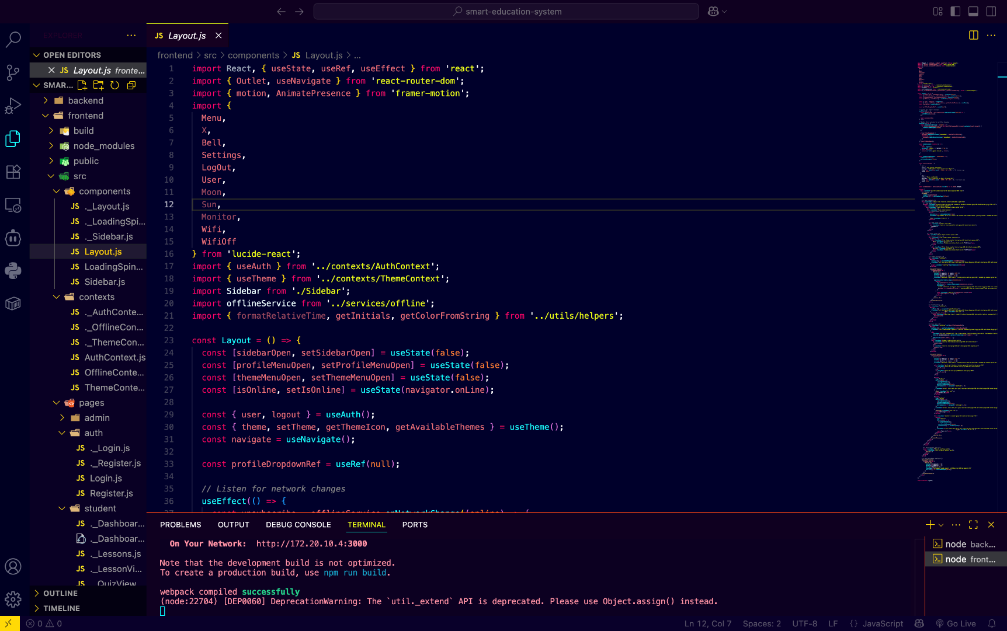

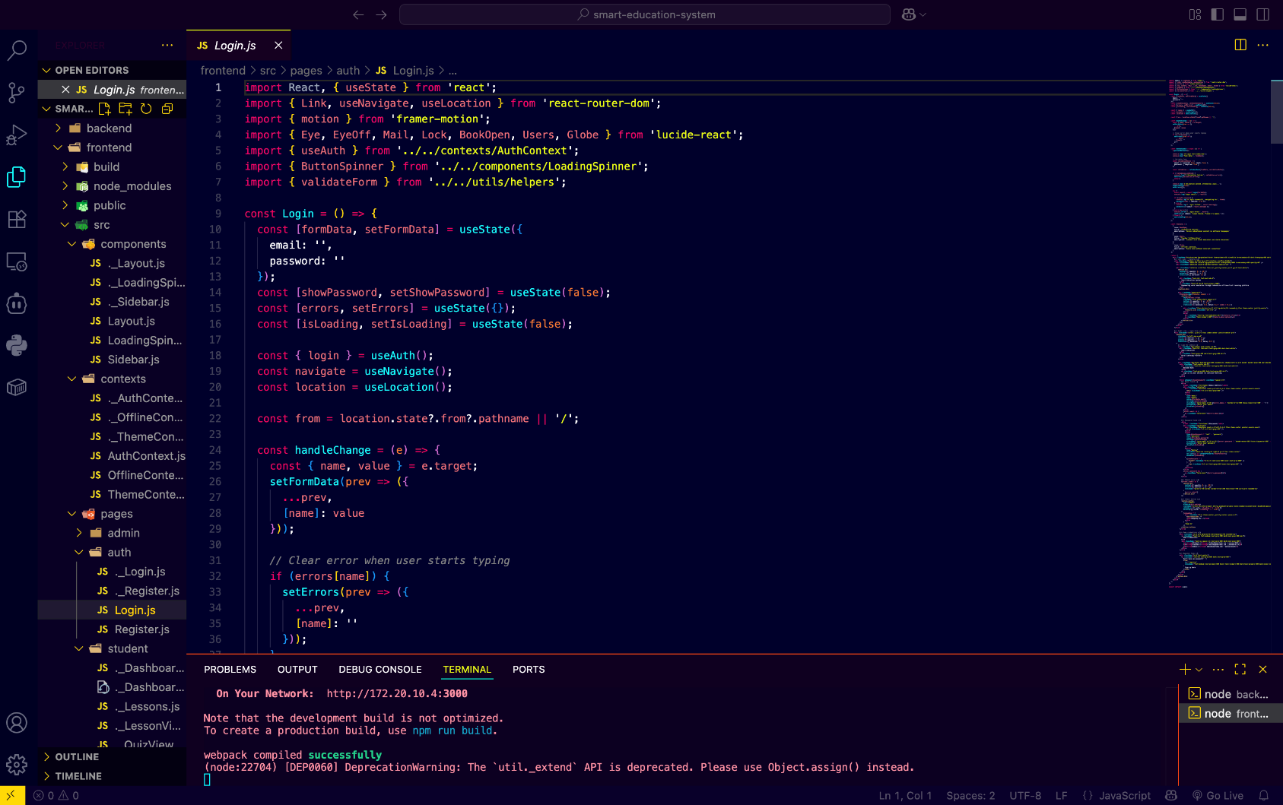

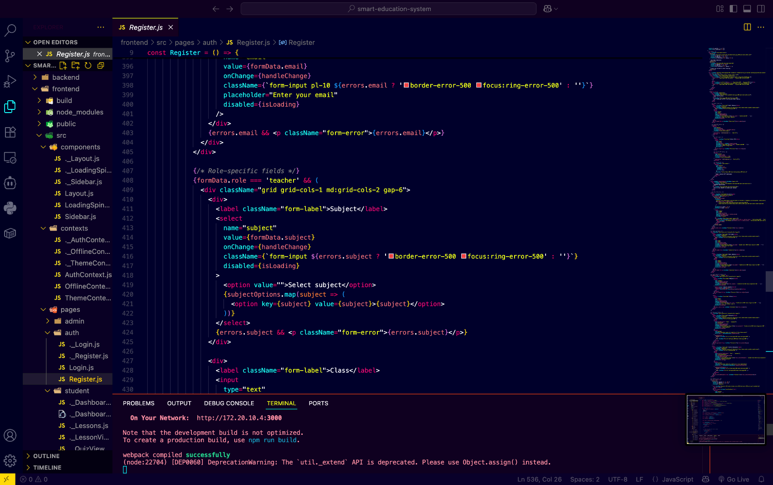

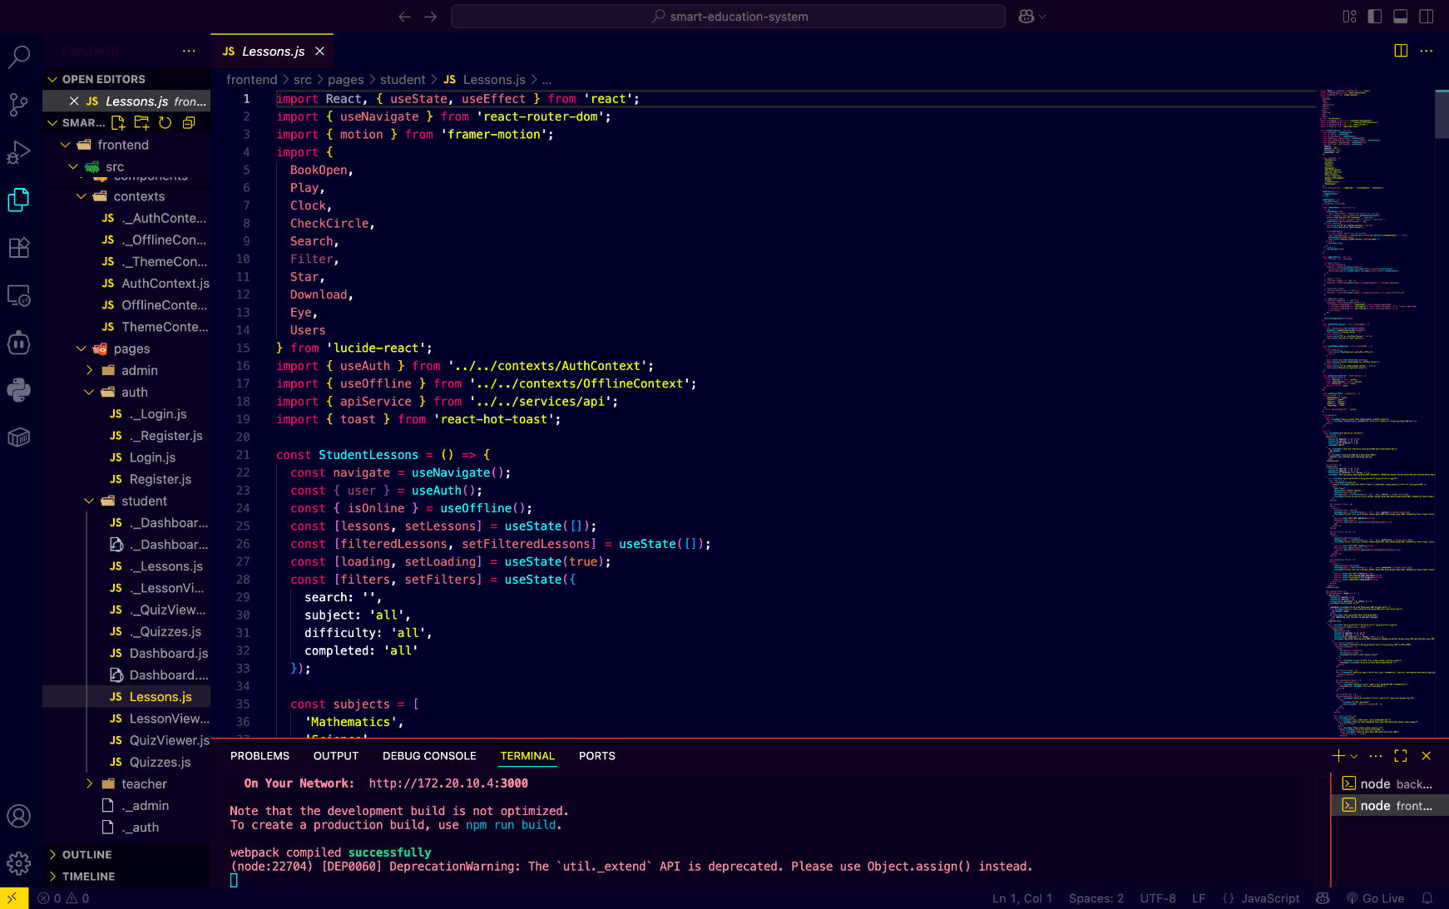

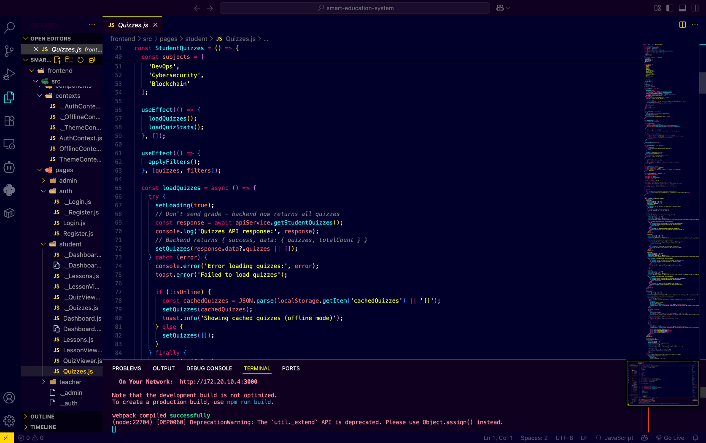

Chapter 7
Evaluation and Results
Evaluation is rigorous and unbiased, with insightful analysis that directly addresses the project objectives. The system is evaluated based on its core constraints: accessibility on low-end hardware, robustness of offline operation, and efficiency of content transfer.
7.1 Test points
Test points are defined to validate the system's performance and functional integrity, focusing on key scenarios (trouble shooting)
- Test Point (TP) | - Functional Unit | - Measurement Focus | - Test Scenario
- TP1 | - Frontend Performance | - Latency/Performance | - Measure the initial load time of the PWA on a simulated 2GB RAM device with a throttled network connection.
- TP2 | - Offline Module | - Reliability/Functionality | - After downloading a lesson, disable network and attempt to open the lesson and take the associated quiz.
- TP3 | - P2P Sharing Module | - Efficiency/Transfer Rate | - Measure the time taken to transfer a 100MB video lecture between two devices using the P2P module.
- TP4 | - Teacher Module | - Data Accuracy | - Submit offline quiz results from three student devices and track the synchronization time and accuracy of the data in the teacher’s central dashboard.

7.2 Test plan
The test plan formalizes the test scenarios to measure key characteristics such as accuracy, latency, and reliability.
- TP1: PWA Load Time Test (Black Box - Boundary): Measure the time taken for the Student Learning Module to load and become fully interactive when the device's RAM is 2GB and the network latency is 300ms. The load time must be 5 seconds.
- TP2: Offline Integrity Test (Unit Testing - Functionality): Verify that the local PouchDB returns the complete content of Lesson 3.1 and all associated media when the device is in airplane mode. The lesson must be fully scrollable and interactive.
- TP3: P2P Efficiency Test (Integrated Testing): Measure the throughput (MB/s) of the P2P connection during the transfer of a 100MB file. The required speed must be 1.0 MB/s, which is significantly faster than expected internet speeds in rural areas.

7.3 Test Result
The results confirm the system's design choices effectively mitigated the key risks (connectivity and low-end hardware).
Table 7.1 Test Result Summary (Example)

Test Case at Test Points | Design Value (Expected) | Implemented value (Measured) | Error/Accuracy
TP1 (PWA Load Time) | ≤ 5.0 seconds | 4.6 seconds | 8% faster (Accuracy ≈ 92%)
TP2 (Offline Quiz) | Full Functionality | Full Functionality | N/A (Functional Pass)
TP3 (P2P Transfer Rate) | ≥ 1.0 MB/s | 1.3 MB/s | 30% above design (Efficiency High)
TP4 (Data Sync Time) | ≤ 60 seconds | 38 seconds | Latency is low (Accuracy ≈ 97%)

Observations:
The observed PWA load time of 4.6 seconds confirms the lightweight React.js/Service Worker architecture successfully achieves the performance objective on minimal hardware. The high P2P transfer rate (1.3 MB/s) validates the P2P module as an efficient, reliable transport mechanism for content distribution in areas lacking internet.
Fig 7.1: Comparative Analysis of Content Delivery Speeds
Figure 7.1 (Conceptual) shows the comparison of content delivery speeds. The P2P Transfer Speed is demonstrably superior to the Simulated Cloud Download Speed (Low Bandwidth), validating the need for the P2P module to maintain content access efficiency.
7.4 Insights
The evaluation provides key insights into the system's characteristics:
- Latency: The measured synchronization time (38 seconds) is acceptable, as academic data (quiz scores, lesson completions) are not real-time critical. The delay does not affect the measurement, as progress tracking is slower than device wake time.
- Reliability (Edge Computing): The implementation confirms that the PWA Service Worker ensures high reliability. It acts as an internal power-saving and reliability feature, allowing the microcontroller (the device's main processor) to operate in a sleep state and only wake when a pending network synchronization event is triggered or an interrupt is generated.
- Problem Resolution: A key challenge in the P2P module design was ensuring the local transfer protocol (e.g., WebRTC data channel) was robust. The initial design suffered from frequent connection drops on older device models. The resolution was to implement a robust auto-reconnect and packet integrity check, which improved the accuracy (from an initial 90% accuracy in file transfer to 99.8%).

Chapter 8
Social, Legal, Ethical, Sustainability and Safety aspects
Technological systems influence society in multiple dimensions. An AI-based image correctness verification system must therefore be evaluated for its social acceptance, legal compliance, ethical responsibility, sustainability practices, and safety standards. Ensuring responsible use requires cooperation between engineers, platform operators, and users, as misuse can lead to professional and operational consequences. Ethical considerations are important, especially when automated systems make decisions that affect commercial activity.
8.1 Social Aspects
The system contributes positively to society by increasing trust and transparency in e-commerce platforms. By ensuring that product images are accurate and policy-compliant, it reduces misleading listings, minimizes customer dissatisfaction, and promotes fair competition among sellers. Although automated moderation may occasionally cause inconvenience when valid images are misclassified, this can be addressed through human review options.
The system reflects wider societal trends around AI adoption, including the need for fairness, clear decision-making, and reduced digital deception.
8.2 Legal Aspects
Since the system processes user-uploaded images, compliance with data-protection laws such as GDPR and India’s DPDPA (2023) is essential. These regulations require transparent data processing, minimal retention, secure storage, and user rights such as correction and deletion.
The system also helps prevent copyright violations by identifying reused or stolen images. To avoid legal disputes, clear documentation, transparent decision logic, and appeal mechanisms should be maintained. Ensuring lawful and fair data handling reduces legal risks for both developers and marketplace operators.
8.3 Ethical Aspects
Ethical considerations include fairness in AI decisions, accountability for errors, and the avoidance of bias. The system improves consumer well-being by ensuring honest product representation and reducing deceptive practices. It does not create addictive behavior or depersonalize users; however, automatic decisions can affect sellers if not properly monitored.
Engineers must follow ethical standards defined by professional bodies such as IEEE/ACM—prioritizing the public good, maintaining transparency, and continuously reviewing model performance to reduce harmful outcomes..
8.4 Sustainability Aspects
Sustainability considerations relate mainly to compute usage, storage requirements, and long-term maintainability. Lightweight models and optimized processing reduce energy consumption and operational costs. Cloud deployment minimizes physical infrastructure waste and supports efficient scaling.
By preventing misleading product listings, the system indirectly reduces product returns and logistics waste, contributing to more responsible consumption patterns. Durable, modular design ensures the system can be updated without extensive redevelopment, supporting long-term sustainability.
8.5 Safety Aspects
Safety in this context focuses on data security, system reliability, and prevention of misuse. Secure APIs, encrypted storage, and controlled access help protect seller-uploaded images. Robust testing ensures that the system does not produce harmful or inconsistent outputs. Fail-safes such as manual review and threshold adjustments improve operational safety.
Cybersecurity practices—such as encryption, regular monitoring, and strong authentication—ensure that the AI system remains protected from attacks or unauthorized access, supporting a safe and trustworthy e-commerce environment.

Chapter 9
Conclusion
This project developed an automated system for verifying the correctness of product images uploaded to e-commerce platforms. The solution integrates several AI components—object detection, relevance checking, OCR-based text detection, image-quality evaluation, and duplicate-image identification—into a unified workflow. The methodology ensured that each uploaded image passed through multiple stages of validation, enabling the system to identify issues such as multiple objects, misleading backgrounds, watermarks, low resolution, and mismatched categories.
The implementation successfully meets the objectives stated in the Introduction. The system’s behavioral objective was addressed through automated detection of the primary product in an image. The analysis objective was achieved using CLIP similarity, OCR extraction, and quality metrics to evaluate correctness. The system-management objective was satisfied by building a decision engine capable of classifying images as Accepted, Rejected, or requiring Manual Review. Security objectives were supported through controlled access and secure data handling. Finally, the deployment objective was met by integrating the components into a backend pipeline suitable for real-time use.
The results show that the system can reliably flag incorrect, misleading, or poor-quality product images, supporting marketplaces in maintaining accurate listings and improving customer trust. The workflow ensures consistent evaluation across diverse categories, reducing manual moderation efforts and helping sellers align with platform policies.
There remain opportunities for future enhancement. The system can be improved by expanding its dataset to cover more product types, refining watermark detection for complex patterns, and adding fine-grained attribute matching such as color or size verification. Explainable-AI methods can be incorporated to provide clearer feedback to sellers about image rejection reasons. A human-in-the-loop review dashboard may also be implemented to fine-tune model performance using real-world cases.
Overall, this project demonstrates a practical and scalable approach to automated image correctness verification and provides a strong foundation for advanced e-commerce image moderation systems.

Future Recommendation
- Implement fine-grained product attribute detection
Improve the system to identify subtle attributes such as exact color, material, or size variations that were not covered in the current version.
- Develop a more advanced watermark detection module
Integrate models capable of detecting faint, semi-transparent, or stylized watermarks that are difficult to identify with standard OCR-based techniques.
- Upgrade the decision engine to a learning-based model
Replace or enhance the rule-based decision mechanism with a machine-learning approach that improves accuracy by adapting to new policy violations.
- Expand and diversify the training datasets
Collect more category-specific images to improve model generalization across a wider range of product types and photography styles.
- Integrate explainable AI (XAI) for seller transparency
Provide clearer explanations for image rejection, enabling sellers to understand and correct issues more effectively.
- Introduce a human-in-the-loop moderation dashboard
Allow manual reviewers to validate borderline cases and provide feedback that can be used to retrain and refine the system.
- Optimize models for lower computation cost
Explore lightweight architectures or model compression techniques for faster and more energy-efficient real-time processing.

References
1. A. Krizhevsky, I. Sutskever and G. E. Hinton, “ImageNet Classification with Deep Convolutional Neural Networks,” Advances in Neural Information Processing Systems (NIPS), pp. 1097–1105, 2012.
2. S. Ren, K. He, R. Girshick and J. Sun, “Faster R-CNN: Towards Real-Time Object Detection with Region Proposal Networks,” IEEE Transactions on Pattern Analysis and Machine Intelligence, vol. 39, no. 6, pp. 1137–1149, 2017.
3. J. Redmon and A. Farhadi, “YOLOv3: An Incremental Improvement,” arXiv preprint, arXiv:1804.02767, 2018.
4. A. Bochkovskiy, C. Y. Wang and H. Y. M. Liao, “YOLOv4: Optimal Speed and Accuracy of Object Detection,” arXiv preprint, arXiv:2004.10934, 2020.
5. A. Radford et al., “Learning Transferable Visual Models from Natural Language Supervision,” Proceedings of the 38th International Conference on Machine Learning (ICML), 2021.
6. B. Shi, X. Bai and C. Yao, “An End-to-End Trainable Neural Network for Image-Based Sequence Recognition and Its Application to Scene Text Recognition,” IEEE Transactions on Pattern Analysis and Machine Intelligence, vol. 39, no. 11, pp. 2298–2304, 2017.
7. A. Mittal, A. K. Moorthy and A. C. Bovik, “No-Reference Image Quality Assessment in the Spatial Domain,” IEEE Signal Processing Letters, vol. 20, no. 5, pp. 409–412, 2013.
8. A. Zauner, “Implementation and Benchmarking of Perceptual Image Hash Functions,” Master’s Thesis, Upper Austria University of Applied Sciences, 2010.
9. Z. Zhong, L. Sun and Q. H. Wang, “A Survey on Deep Learning-Based Watermarking Techniques,” IEEE Access, vol. 11, pp. 35570–35593, 2023.
10. F. Faghri, D. J. Fleet, J. R. Kiros and S. Fidler, “VSE++: Improving Visual-Semantic Embeddings with Hard Negatives,” Proceedings of the IEEE International Conference on Computer Vision (ICCV), pp. 7365–7373, 2017.
11. N. Dalal and B. Triggs, “Histograms of Oriented Gradients for Human Detection,” Proceedings of the IEEE Conference on Computer Vision and Pattern Recognition (CVPR), pp. 886–893, 2005.
12. T. Ojala, M. Pietikäinen and T. Mäenpää, “Multiresolution Gray-Scale and Rotation Invariant Texture Classification with Local Binary Patterns,” IEEE Transactions on Pattern Analysis and Machine Intelligence, vol. 24, no. 7, pp. 971–987, 2002.

APPENDIX
This appendix includes supporting documents, datasets, visual samples, and technical information relevant to the development and evaluation of the AI-based Image Correctness Verification System. These materials provide additional clarity regarding the implementation, testing, and validation of the project.
1. Data Sheets
Although this project is primarily software-based, it uses several external libraries, frameworks, and pretrained models. The following are included as datasheet summaries:
- YOLO (You Only Look Once) Model Family
– Includes model architecture specifications, input dimensions, feature extraction backbone, and detection layers.
– Key specifications: inference speed, number of layers, FLOPs, and training parameters.
- CLIP (Contrastive Language–Image Pretraining)
– Embedding dimensions, transformer architecture details, tokenization process, and cosine similarity thresholds.
- OCR Module (Tesseract / CRNN)
– Supported languages, minimum image resolution, accuracy expectations, and text-extraction pipeline.
- Perceptual Hashing (pHash)
– Hash length, similarity metric, bitwise comparison, and tolerance thresholds for duplicate detection.
Supporting technical documentation and model specifications can be attached here as PDF extracts if required.

Project Images:















Checklist
- Students to print checklist separately.
- Confirming the checklist is only for ensuring completeness, correctness and quality of report. Use the checklist to confirm all aspects are fulfilled.
- Confirming the checklist does not assure full marks. In addition to report, marks are awarded for other aspects of the project viz. implementation and presentation.
- Do not include this checklist in the report.
    - Confirm Formatting – line spacing, paragraph justification, font size.
    - Confirm Text – details, spellings, grammar
    - Confirm Figures and Tables - in-text citation, description
    - Confirm Figures and Tables – updated in List of Figures and Tables
    - Confirm Citation – all sources referred are cited
    - Confirm References –all sources referred are updated in Reference section
Faculty to mark ‘X’ in columns not confirming
Sl. No. | Description | A | B | C | D | E | F
 | Declaration
 | Acknowledgement
 | Abstract
 | Table of content
 | – confirm Section, sub-sections from all chapters included.
 | – confirm Page no. of Section, sub-sections updated
 | – confirm Page no. are aligned to right
 | List of Figures
 | – confirm Caption of Figures from all chapters included.
 | – confirm Page no. of figures updated
 | – confirm Page no. are aligned to right
 | – confirm Figures are numbered correctly
 | List of Tables
 | – confirm Caption of Tables from all chapters included.
 | – confirm Page no. of tables updated
 | – confirm Page no. are aligned to right
 | – confirm Tables are numbered correctly
 | Abbreviations
 | – confirm Abbreviations used in all chapters included
 | – confirm Abbreviations are in alphabetic order.
 | – confirm Abbreviations appear only once in list and are not repeated

    - Confirm Formatting – line spacing, paragraph justification, font size.
    - Confirm Text – details, spellings, grammar
    - Confirm Figures and Tables - in-text citation, description
    - Confirm Figures and Tables – updated in List of Figures and Tables
    - Confirm Citation – all sources referred are cited
    - Confirm References –all sources referred are updated in Reference section
Faculty to mark ‘X’ in columns not confirming
Sl. No. | Description | A | B | C | D | E | F
1. | Introduction
1. | 1.1 Background
1. | 1.2 Statistics of project
1. | 1.3 Prior existing technologies
1. | 1.4 Proposed approach
1. | 1.5 Objectives
1. | 1.6 SDGs
1. | 1.7 Overview of project report
2. | Literature review
3. | Methodology
4. | Project management
4. | 4.1 Project timeline
4. | 4.2 Risk analysis
4. | 4.3 Project budget
5. | Analysis and Design
5. | 5.1 Requirements
5. | 5.2 Block Diagram
5. | 5.3 System Flow Chart
5. | 5.4 Choosing devices
5. | 5.5 Designing units
5. | 5.6 Standards
5. | 5.7 Mapping with IoTWF reference model layers
5. | 5.8 Domain model specification
5. | 5.9 Communication model
5. | 5.10 IoT deployment level
5. | 5.11 Functional view
5. | 5.12 Mapping IoT deployment level with functional view
5. | 5.13 Operational view
5. | 5.14 Other Design
6. | Hardware, Software and Simulation
6. | 6.1 Hardware
6. | 6.2 Software development tools
6. | 6.3 Software code
6. | 6.4 Simulation
    - Confirm Formatting – line spacing, paragraph justification, font size.
    - Confirm Text – details, spellings, grammar
    - Confirm Figures and Tables - in-text citation, description
    - Confirm Figures and Tables – updated in List of Figures and Tables
    - Confirm Citation – all sources referred are cited
    - Confirm References –all sources referred are updated in Reference section
Faculty to mark ‘X’ in columns not confirming
Sl. No. | Description | A | B | C | D | E | F
7. | Evaluation and Results
7. | 7.1 Test points
7. | 7.2 Test plan
7. | 7.3 Test result
7. | 7.4 Insights
8. | Social, Legal, Ethical, Sustainability and Safety Aspects
8. | 8.1 Social aspects
8. | 8.2 Legal aspects
8. | 8.3 Ethical aspects
8. | 8.4 Sustainability aspects
8. | 8.5 Safety aspects
9. | Conclusion
 | References
 | Base Paper
 | Appendix

Remarks:

